UVA 11507 BENDING ROBOT PROBLEM

Explanation of the solution.

First of all you need to get in your mind that ‘+x’ and ‘-x’ command will not change the direction of the rod.

So, only possible operations are +y, -y, +z and –z. In each case just think of rod as a wire which always has some part attached to +x axis and a point in the respective direction. Do not think any part between these two points.

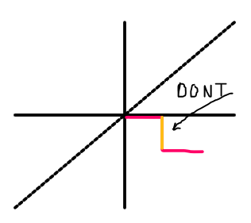 Just think the outcome if we bend the pink coloured line.

For each operation we have 6 unique possible outcomes but out of these, 2 won’t change the direction at all. We will have a look at them in the following examples.

We use this as references; d={0:'+x',1:'-x',2:'+y',3:'-y',4:'+z',5:'-z'}

if i=='+z':  
 if dir==0: dir=4  
 elif dir==1: dir=5  
 elif dir==4: dir=1  
 elif dir==5: dir=0